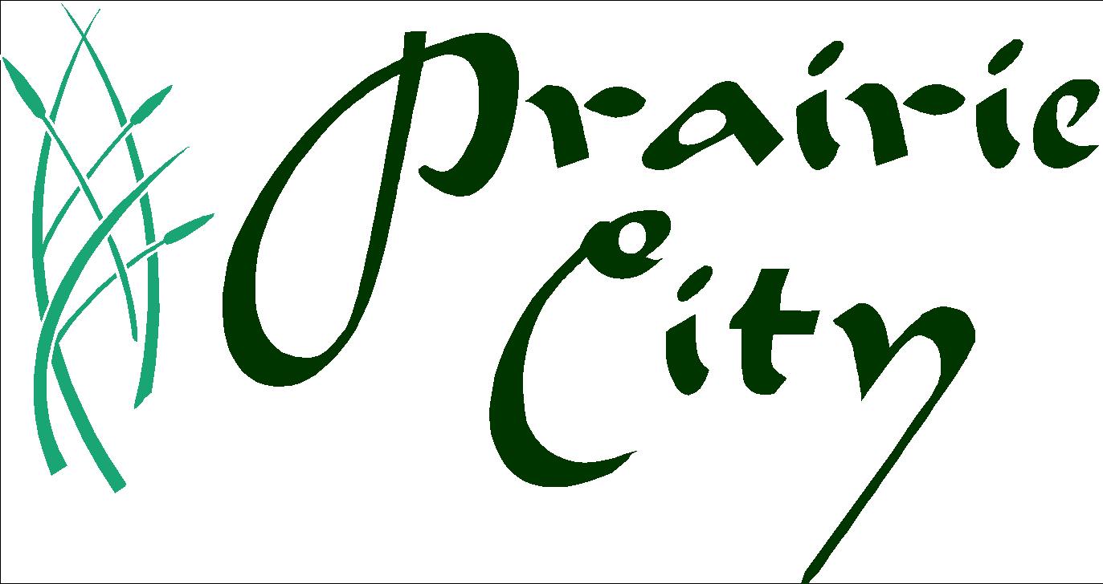
Economic Development Committee
Wednesday, December 2 at 6:00 p.m.
Zoom Conference Call
Agenda
(Subject to change within 24 hours of meeting)

- Call to Order
- Roll Call
- Approval of Agenda
- Approval of Minutes (from Sept 23, 2020 meeting)
- New Business:
  - Members

- Old Business:
  - Electronic Sign
  - Planning and Zoning work
    - Future Land Use project
    - Off-street parking requirements in Downtown Revitalization area
  - Housing Update (Housing development and S Norris St.)
  - Red Rock Prairie Trail Update
  - Real Estate Update Commercial Property update / availability
  - EDC (Corporation) Update
  - JEDCO Update
  - Review and Future Action on
    - Main Street Iowa program
    - Downtown Revitalization Grant Program

- General Discussion

- Next Meeting: January 27, 2021 - 6:00 PM City Hall/Zoom Meeting

- Adjournment

American with Disabilities Act Compliance:
If there is anyone wishing to attend that may require special assistance in being able to participate in this public meeting, please advise City Hall of your needs forty-eight (48) hours prior to the meeting.

