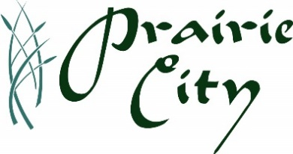
To: Prairie City Resident and Business Representatives
Subject: Open House - Phase 2 Water and Sherman St and Jefferson St Water Projects
Location: Community Center Building
Date/Time: Thursday, February 29, 2024, from 5:00 to 7:00 PM
Hosts: City of Prairie City staff and MSA Engineering staff
Questions: City Hall staff at 515-994-2649

Phase 2 Water Main Project Area – Park St, Orchard St, Clarie St, 9th St, Madison St & 5th St (Orange area)
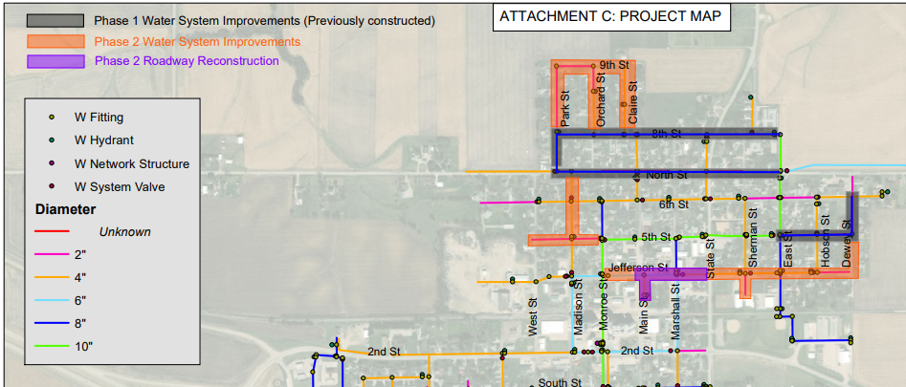
Sherman St and Jefferson St Water Main Project Area – (Approx. Water Main Location within Boxed Area)
